To check and see if the ACH and RMT files have been sent via AIX1 to HP make sure that the files are in the directory below.

Log into bcbsaix1

After logging in switch user

su –

login with root credentials

s2prod/cdunix/eds/gbill_prod/sent

ls –ltr | grep “Dec 04” (example to list current day files)

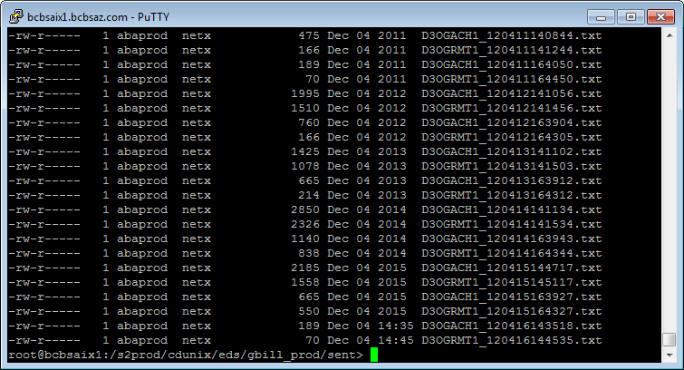

Examples of last two files ACH and RMT have been sent to HP